Lesson: Map Projections

Purpose:
This lesson will explore how objects from a spherical surface are distorted when projected to a flat surface like a map.

Approximate lesson time: 30 minutes

What you will need:
- Globe
- Three large sheets of paper (11x17)
  - Leave on sheet complete (rectangle for cylinder)
  - Cut one into a flattened cone (across the wide portion)
  - Cut one into a circle (as large as possible)
- Scissors
- Masking tape
- 3-D printed model of map projection distortions (Figure 1)
  - Please contact me for 3-D printer file
  - Will need to be printed in advance of the meeting

Introduction of Distortion on Maps:
- Discuss the three basic methods of projecting the globe onto a map (cylindrical, conic, planar)
- Have the student take each sheet of paper and “wrap” it around the globe
  - Tape the edges of the paper in place to hold the paper in place wrapping the paper as best possible around the globe
- Fold triangle shapes into the bulged edges of the paper to finish fitting the paper to the globe as best as possible
- Remove the sheets of paper and cut out the triangle fold representing the overlapping area of the map which would need to be altered
  - Repeat the process for each projection type
- Lay the sheets out flat and have the student feel where and how prevalent the “missing” areas are for each map projection family
- Discuss how each of these missing areas represent areas where the location information needs to be “stretched” to display the spherical information onto a flat map representing the large area

Generalized Distortion by Map Family:
- Have the Map Projections distortion model (Figure 1) 3-D printed or use a 3-D pen or hot glue gun to create a similar flat tactile graphic
  - Note if creating your own image: we created lat-long lines every 30 degrees covering one hemisphere and Printed on a smiley face that extended to 45 degrees in all cardinal directions. This pattern holds for all map projections so they are directly comparable
  - Please use the contact page to acquire a printable file download
- Discuss how the introduction of distortion for each map family would create the different shapes that appear on the different projection families on the 3-D model
  - Cylindrical Family: stretches east-west to a greater extent near the poles creating an ellipse shape
  - Conic Family: stretches eat west to a greater extent I the southern hemisphere creating an egg shape
  - Planar Family: compresses space near the standard point 0 lat, 0 long in this case and stretches further away from the standard point creating a compression in the center and a stretch near the edges of the map

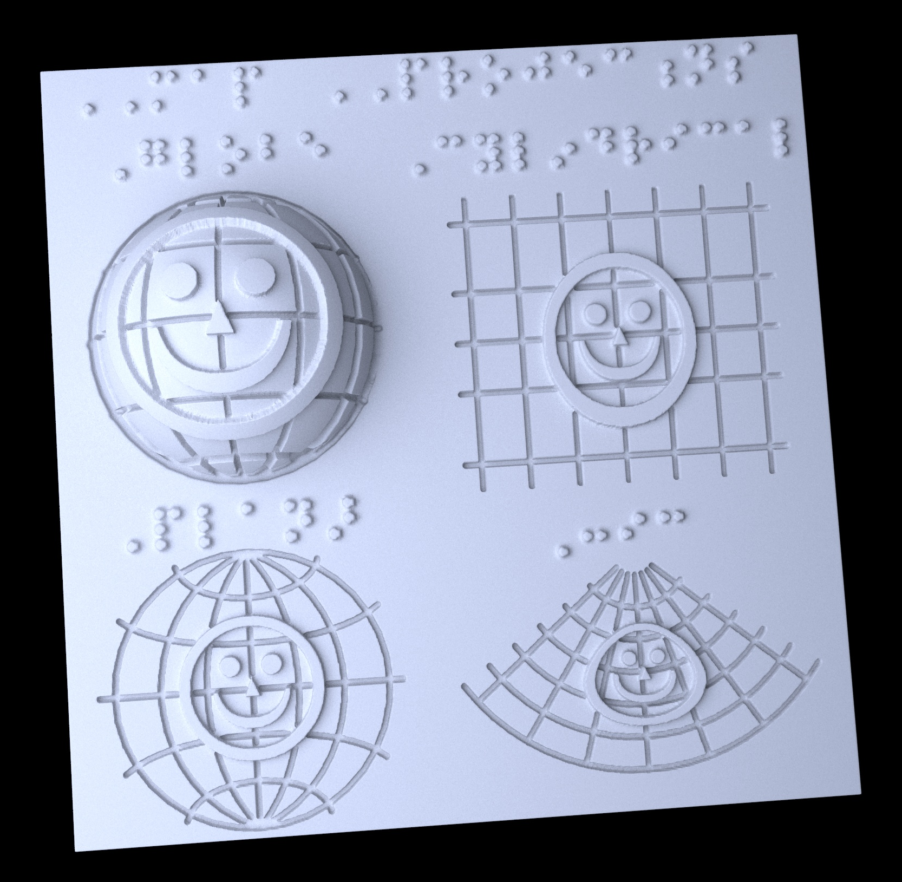
Figure 1: Rendering of 3-D printer model of basic map projection distortions. Please use the contact page to acquire printable file.

